**Streamlining Ticket Assignment for Efficient Support Operations**

Team Id: NM2025TMID14868

Team Members: 5

Team Leader: HARISH S - harish080803@gmail.com

Team Member 2: FAIZAL M - faizal200509@gmail.com

Team Member 3: MADHAN M - madhan.jai003@gmail.com

Team Member 4: SUBASH B - subash1999038@gmail.com

Team Member 5: SRI VATSAN S - srivatsansai1234@gmail.com

**PROBLEM STATEMENT:**

Tickets raised by customers are often delayedif not assigned properly. This project solves that issue by streamlining ticket assignment.

**OBJECTIVE:**

* To understand the process of ticket assignment.
* To learn how to use the Smart Internz portal for guided projects.
* To complete milestone-based tasks for efficient support operations.

**SKILLS:**

* Portal login & navigation
* User, group, and role handling
* Ticket management
* Workflow design

**INTRODUCTION TO THE PROJECT:**

The project “Streamlining Ticket Assignment for Efficient Support Operations” explains how support tickets are managed. A ticket means a customer issue. If not assigned properly it causes delay.

This project is done through the Smart internz Portal. The work is divided into milestones. Each milestone teaches us one step in handling cases.

**#WORKFLOW OF TICKET ASSIGNMENT**

**STEP1:Portal Login and Access**

1. OpenNaan Mudhalvan Portal and login with your username, password and captcha verification.
2. Select the mentorship program (smartBridge) and navigate to courses-> Mandatory course.
3. Under Actions, click watch to open the smart internz portal.

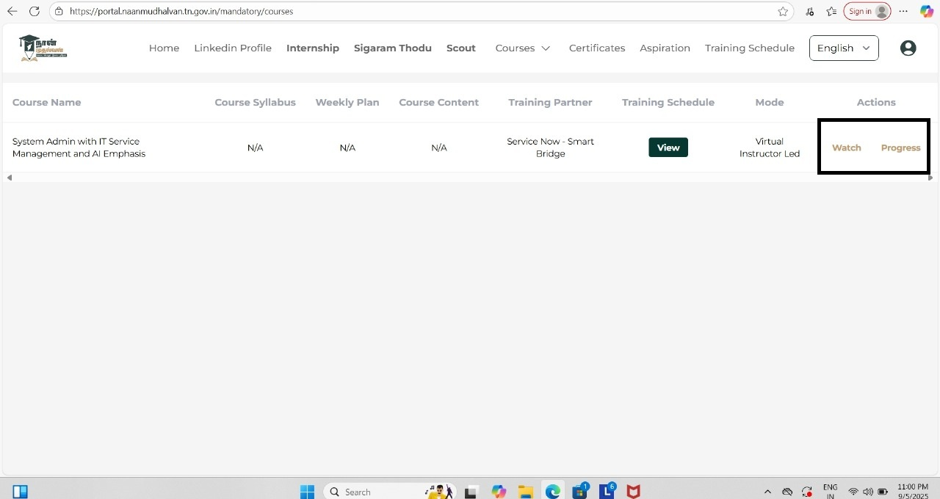

1. In the Smart internz portal, you will see three tabs: Home,Project,Support. Click project.

5 Go to Guided Projects -> Workspaces to view all milestones.

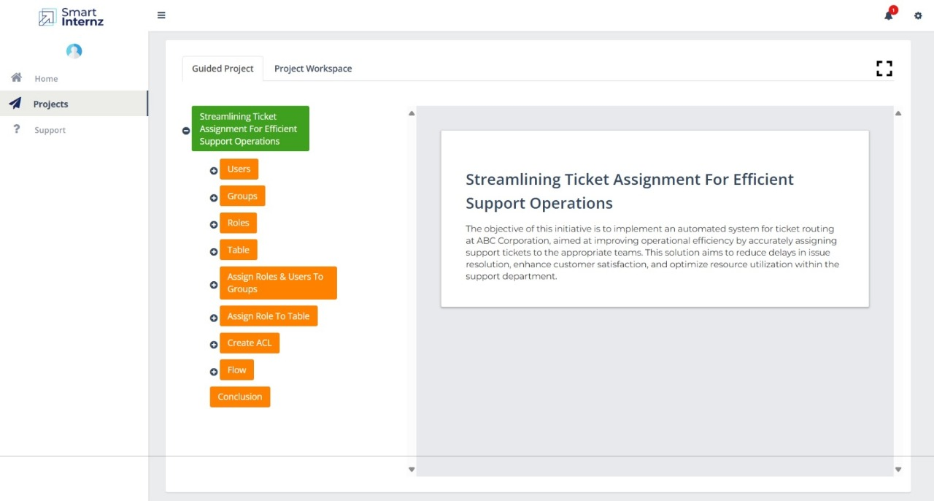

6. The Workspace displays all the project milestones for tracking and completion.

**WORKFLOW INITIATION:**

Milestone1:**Create Users**

1. Login to ServiceNow.
2. Search for Users in the left menu.
3. Click Users under System Security.
4. Press to add new user.
5. Fill details like Name, ID, Email and save.

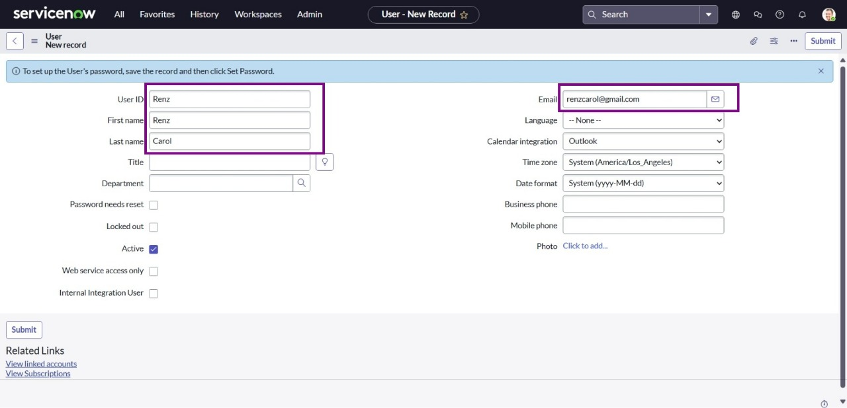

6. Do the same again to create another user.

7. Click on submit.

Milestone 2: **Create Groups**

1. Login to ServiceNow.

2. In the left search box, type Groups.

3. Click on Groups under System Security.

4. Press New to add a group.

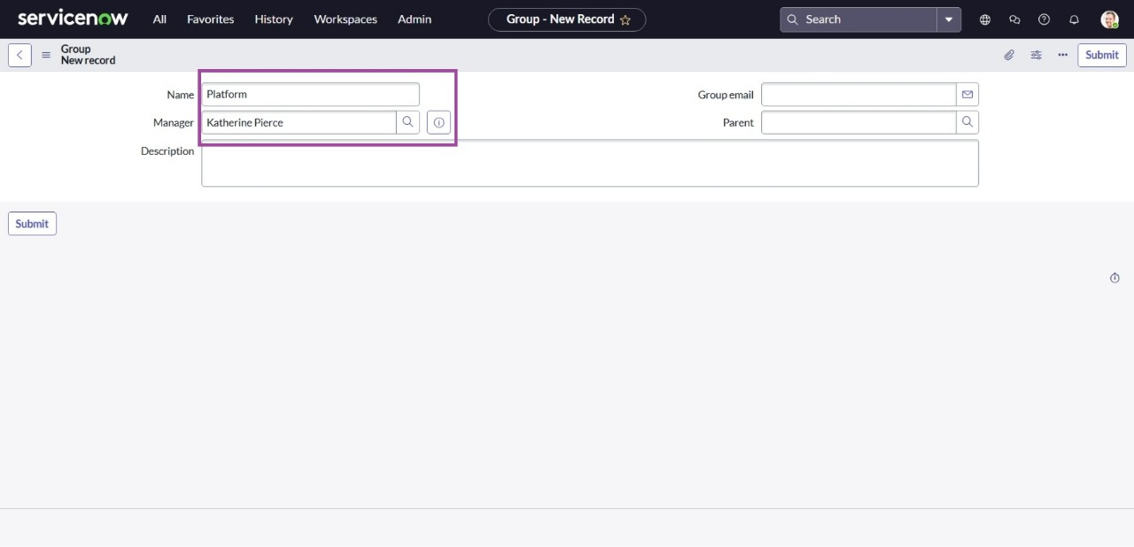

5. Enter the group details.

6. Click Submit to save.

Milestone 3: **Create Roles**

1. Login to ServiceNow.

2. In the search bar, type Roles.

3. Select Roles from the System Security section.

4. Click New to add a role.

5. Enter the role details and save by clicking Submit.

6. Repeat the same steps to create one more role.

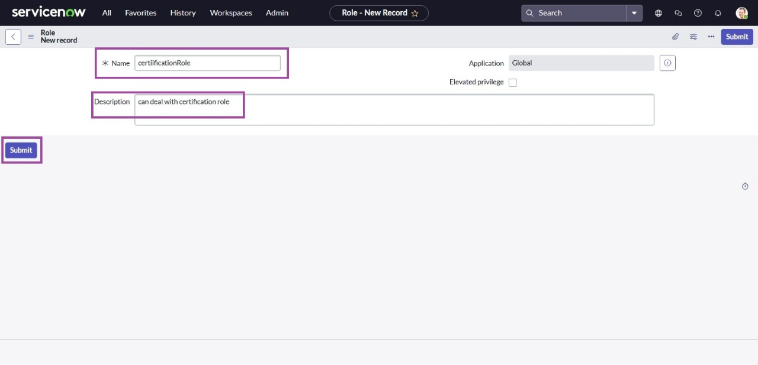

Milestone 4: **Create Table**

1. On the ServiceNow interface, search for Tables in the left panel.

2. Choose Tables under System Definition.

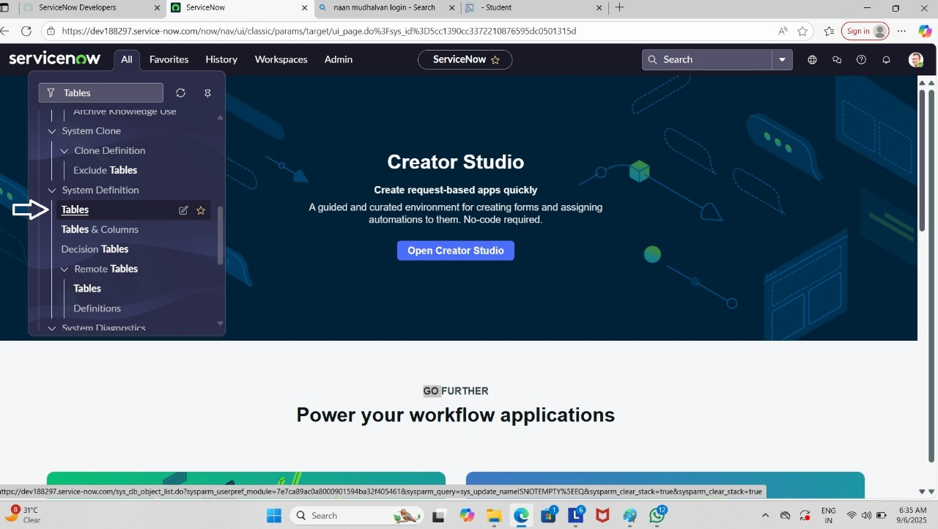

3. Click New to create a table.

4. Enter details like:

Label: Project Table

Check Create module and Create mobile module

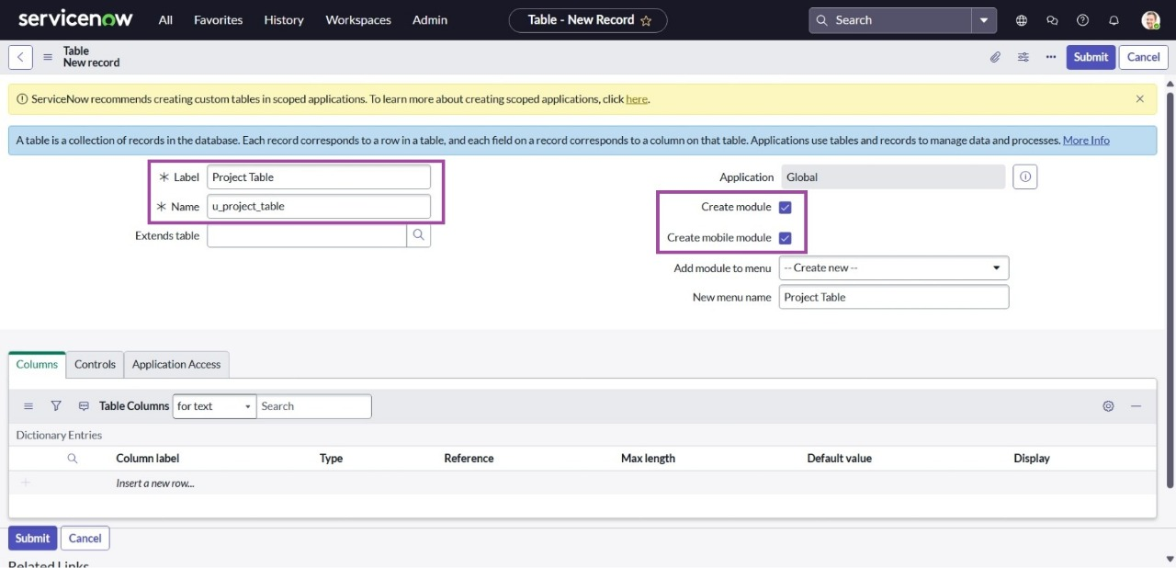

5. Under New Menu Name, type Project Table.

6. Add the required columns for the table.

7. Click Submit to save.

8. Create choices for the issue filed by using form design

Choices are:

* Unable to login platform
* 404 error
* Regarding certificates
* Regarding user expired

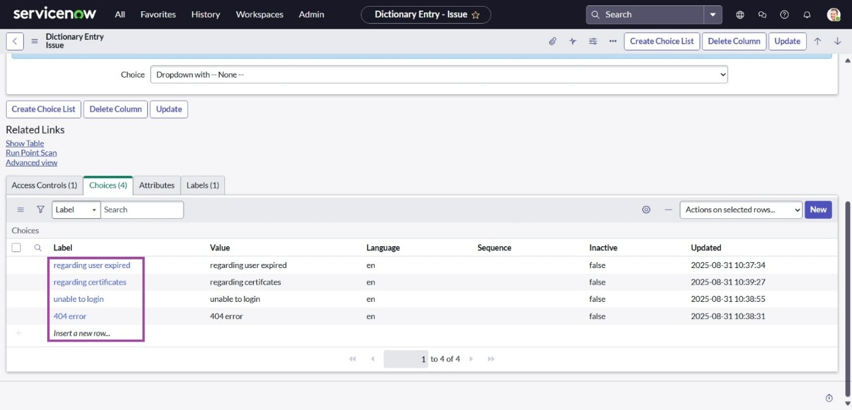

Milestone 5: **Assign Roles & Users**

Activity 1: **Certificate Group**

1. Log in to ServiceNow.

2. From the navigation filter, search for group (under System Definition).

3. Open the Certificates group.

4. In the Group Members section, choose Edit.

5. Add Katherine Pierce and save the changes.

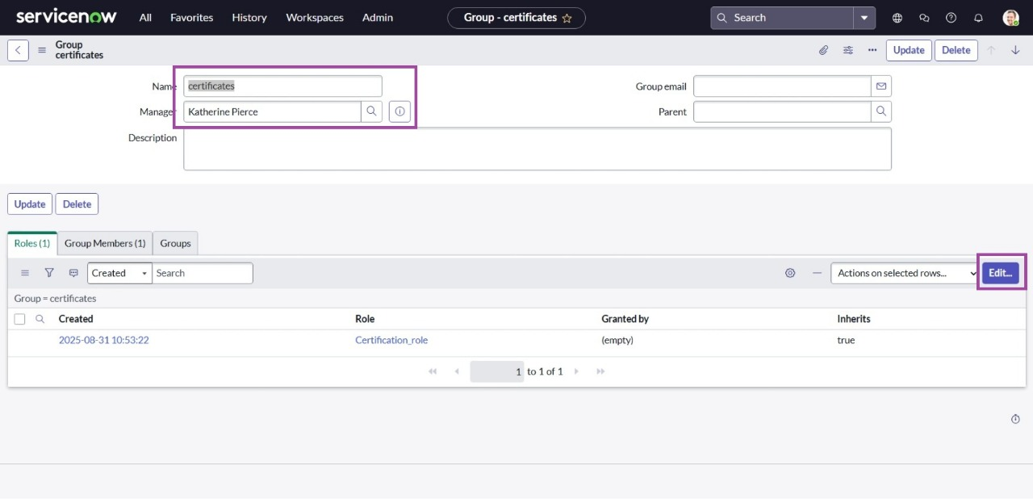

6. Now go to the Roles tab.

7. Assign the Certification role and save.

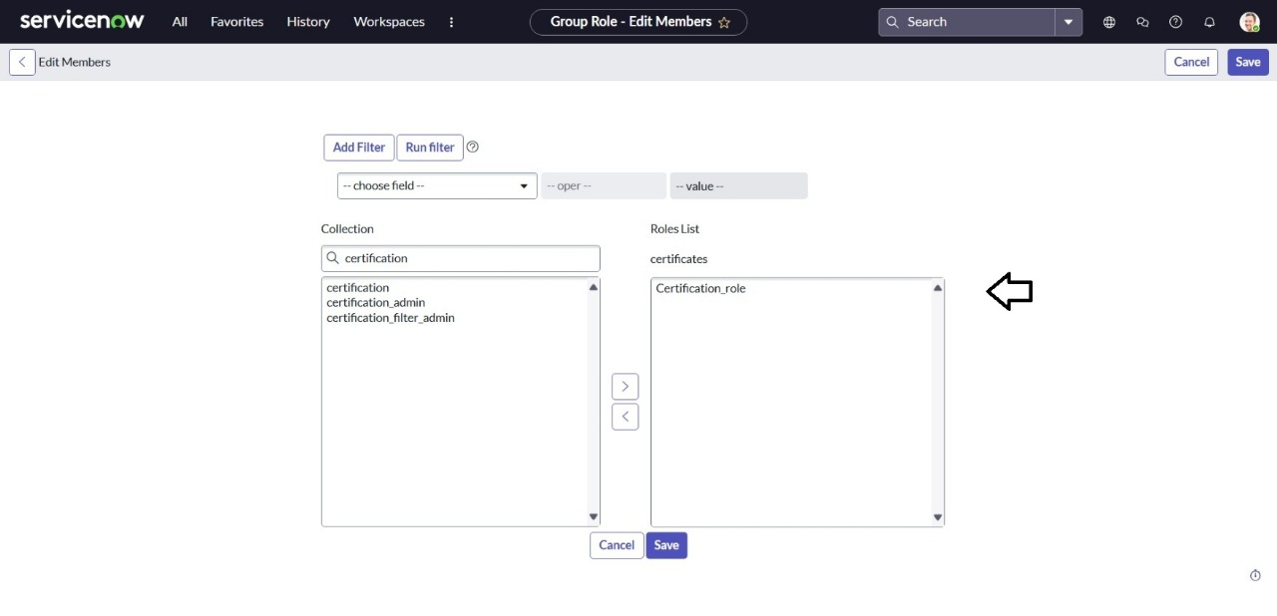

Activity 2:

Assign Roles & Users – **Platform Group**

1. Log in to ServiceNow.

2. Go to groups through the System Definition module.

3. Open the Platform group.

4. Under Group Members, click Edit.

5. Add Manne Niranjan and save.

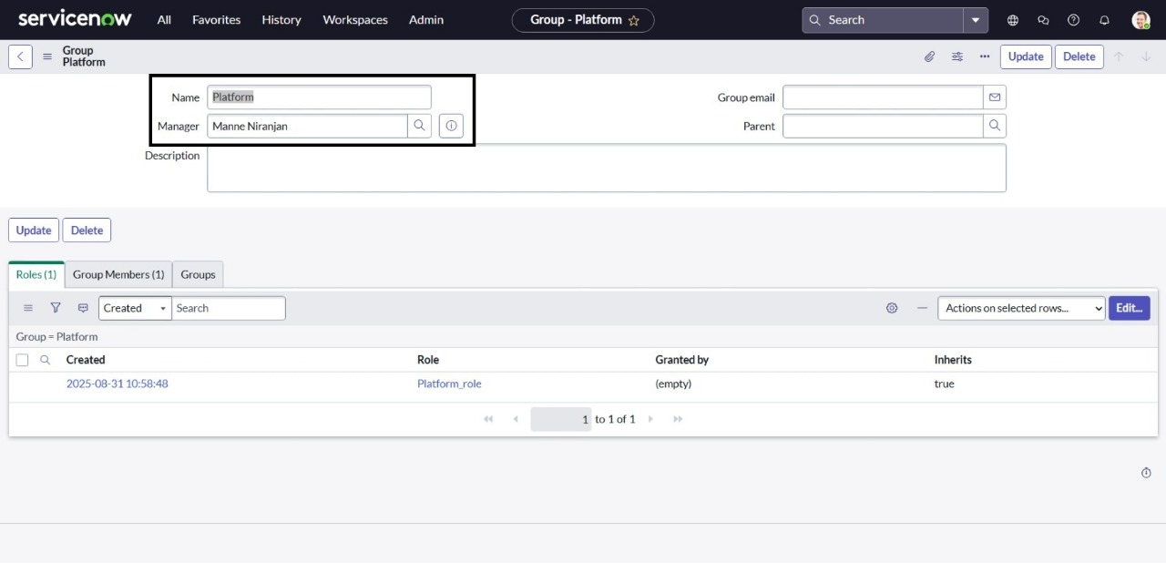

6. Open the Roles section.

7. Assign the Platform role and save.

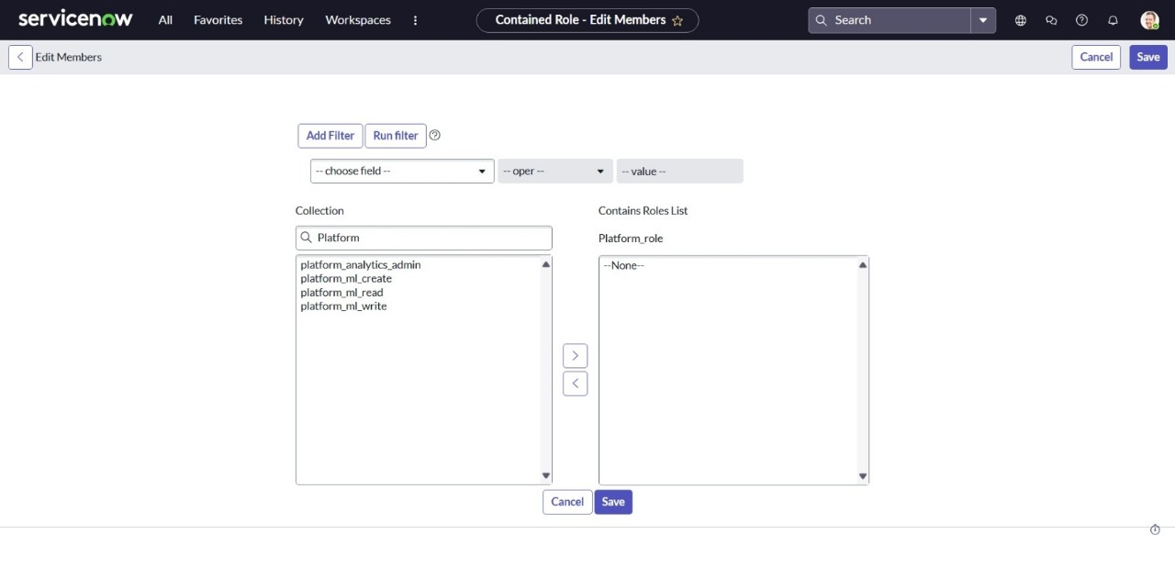

Milestone 6: **Assign Role to Table**:

1. Log in to ServiceNow.

2. From the navigation, go to All → Tables.

3. Open the Operations Related table.

4. Select Application Access.

5. Open u_operations_related – Read operation.

6. Click the profile icon (top-right) choose elevate role.

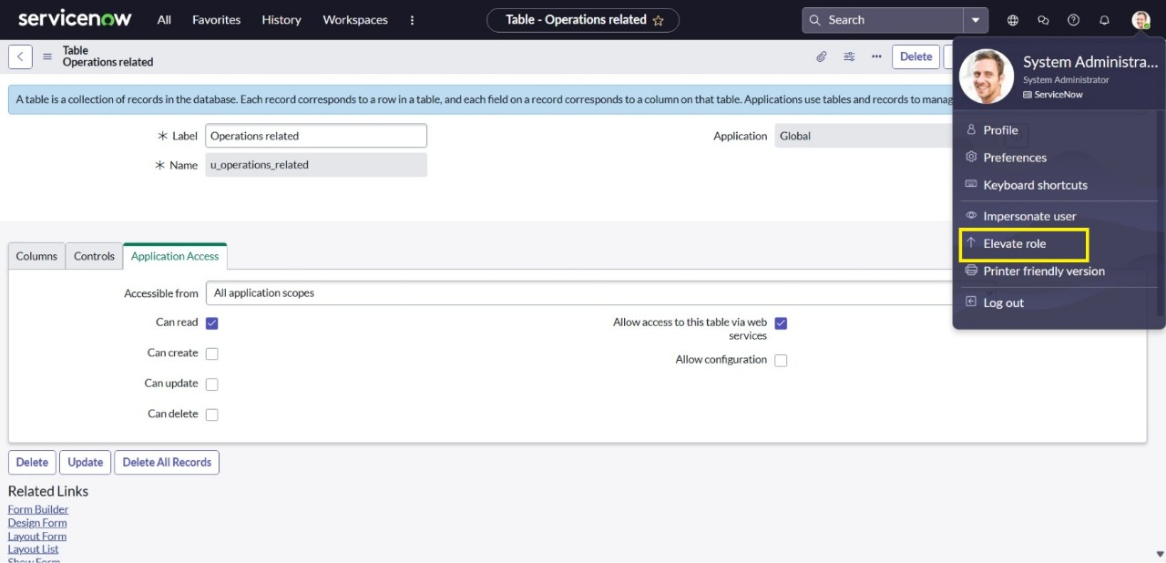

7. Choose Elevate Role → enable Security Admin → click Update.

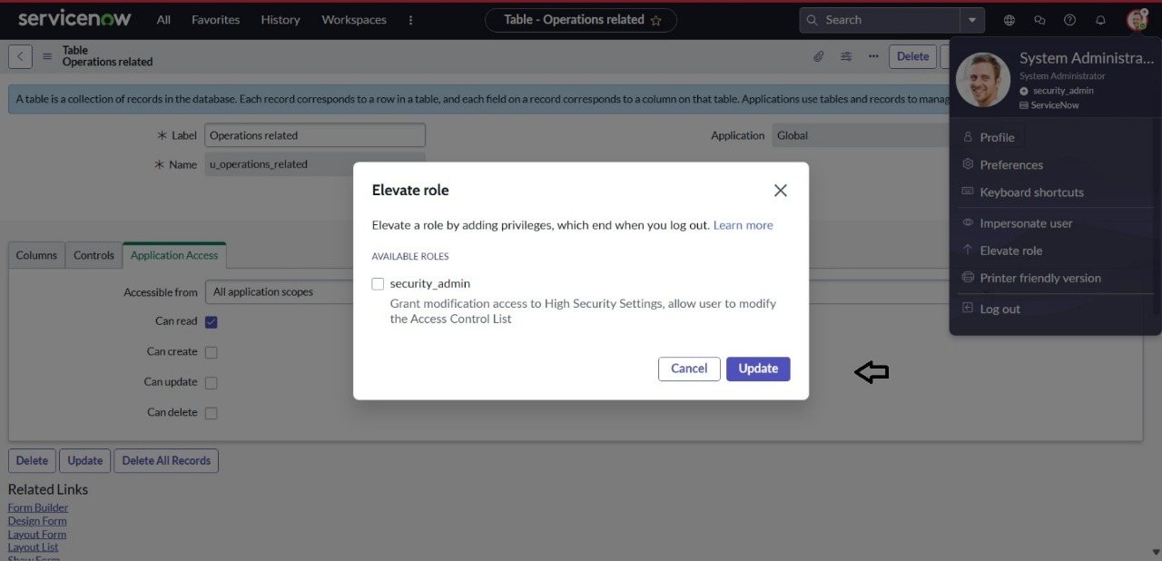

8. In the Requires Role section, double-click to add a new row.

9. Assign Platform role and Certificate role, then save.

10. Now open u_operations_related – Write operation.

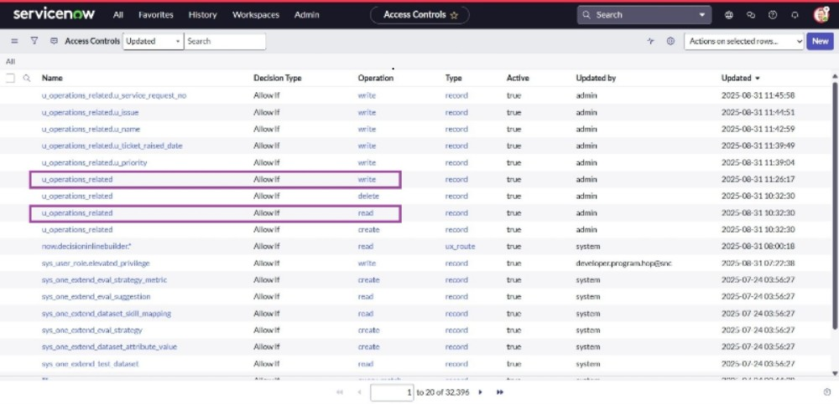

11. Again under Requires Role, double-click to add new rows.

12. Assign Platform role and Certificate role, then save.

Milestone 7: **Create ACL**

1. Log in to ServiceNow.

2. In the navigation filter, search for ACL.

3. Go to Access Control (ACL) under System Security.

4. Click on New.

5. Fill in the required details for creating a new ACL.

6. Scroll down to the Requires Role section.

7. Double-click to insert a new row.

8. Add the required role(s)

9. Click Submit.

10. Similarly, create 4 more ACLs for the remaining fields.

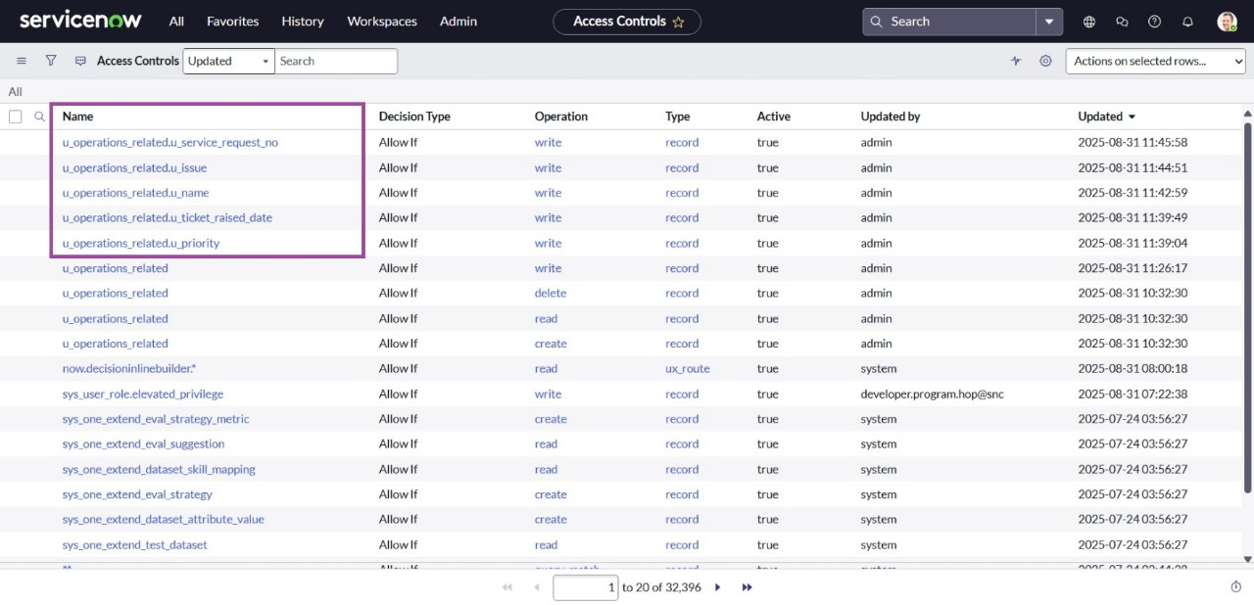

Milestone 8: **Create Flow in Flow Designer**

1. Log in to ServiceNow.

2. Go to All → Flow Designer under Process Automation.

3. Click New → Flow.

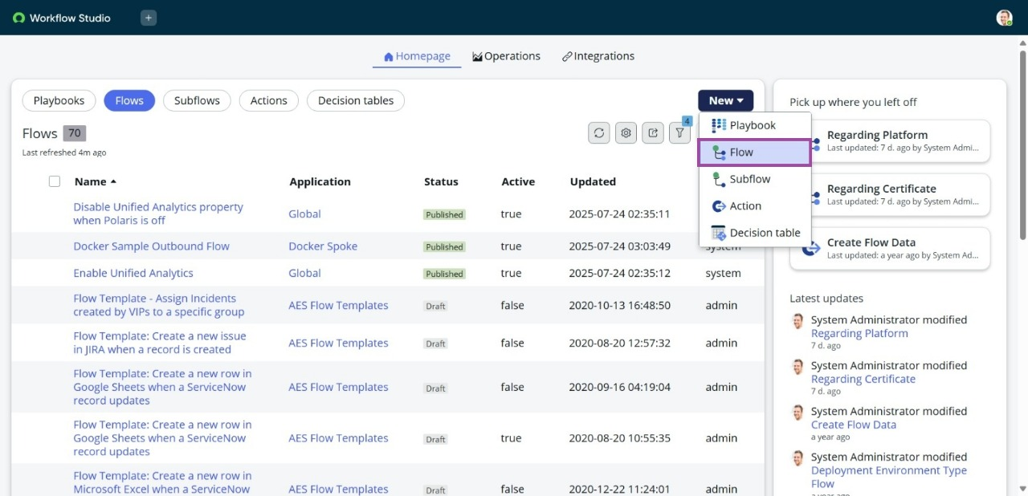

4. In Flow Properties,

* Flow Name: Regarding Certificate
* Application: Global
* Run user: System User

1. Click build flow.

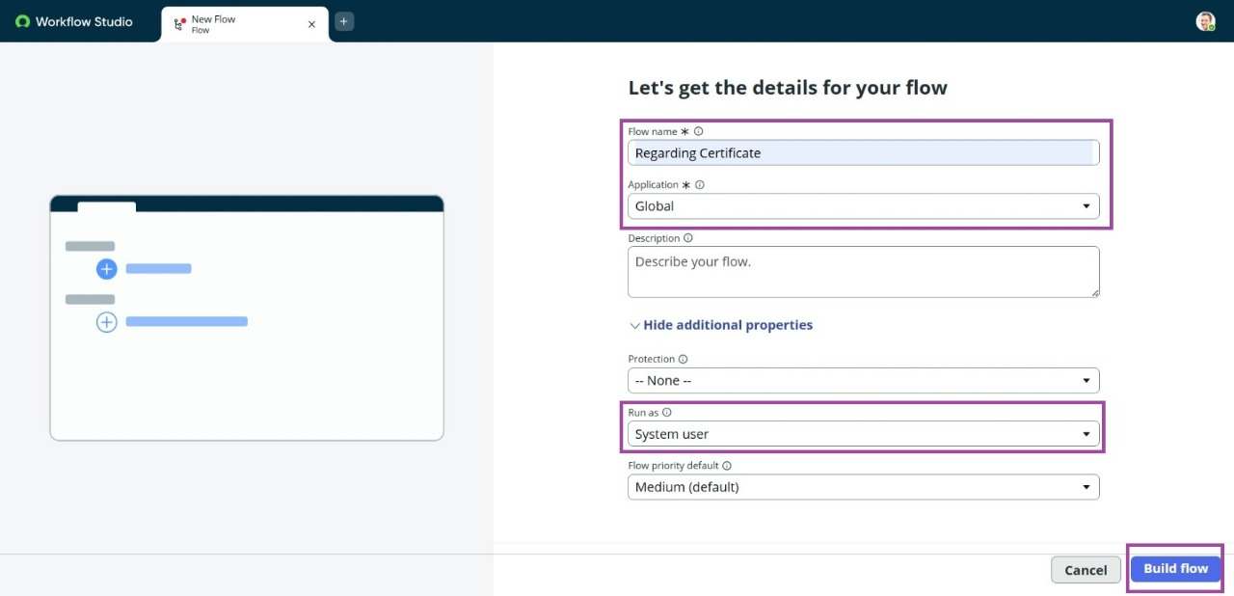

* Add Trigger

6. Click Add a Trigger.

7. Select Create or Update a Record.

8. Set Table: Operations Related.

9. Add Condition:

* Field: Issue
* Operator: is
* Value: Regarding Certificates

10. Click Done.

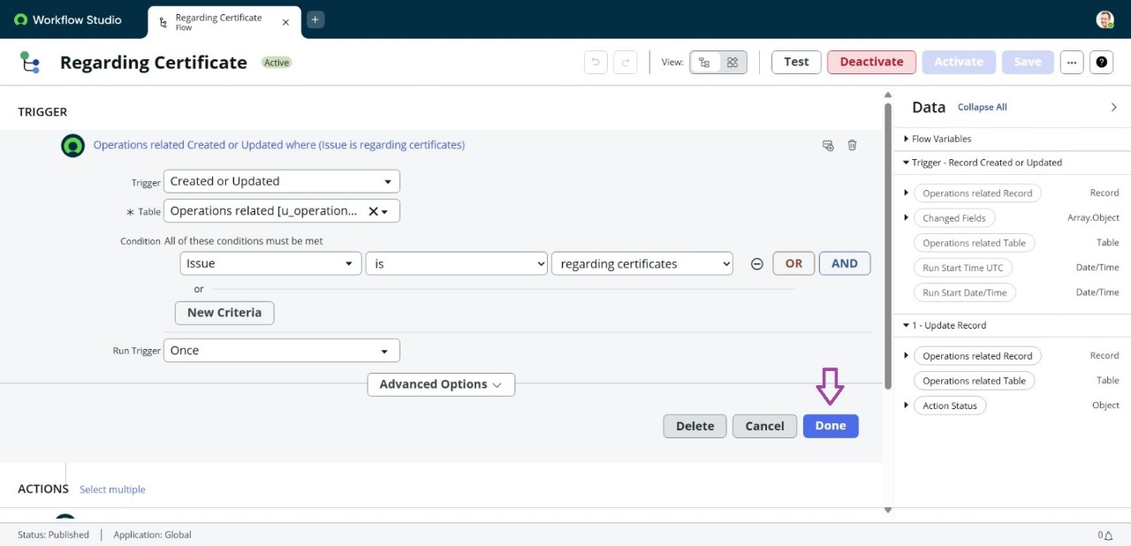

* Add Action

11. Under Actions, click Add an Action.

12. Choose Update Record.

13. In Record fields, drag fields from Data Panel on the left.

14. Table will be auto-assigned.

15. Set field: Assigned to group.

16. Value: Certificates.

17. Click Done.

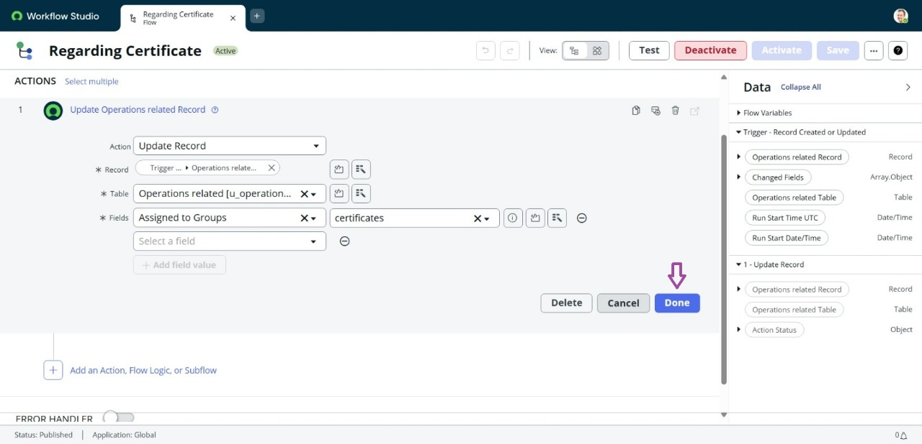

18. Click Save → then Activate the flow.

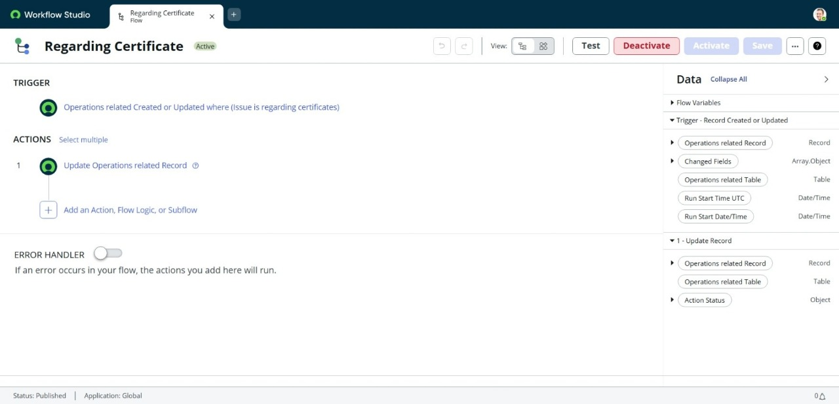

Activity 2: **Create Flow to Assign Operations Ticket to Platform Group.**

1. Log in to ServiceNow.

2. From the navigation, go to All → Flow Designer under Process Automation.

3. Click New → Flow.



4. In Flow Properties, set:

* Flow Name: Regarding Platform
* Application: Global
* Run User: System User

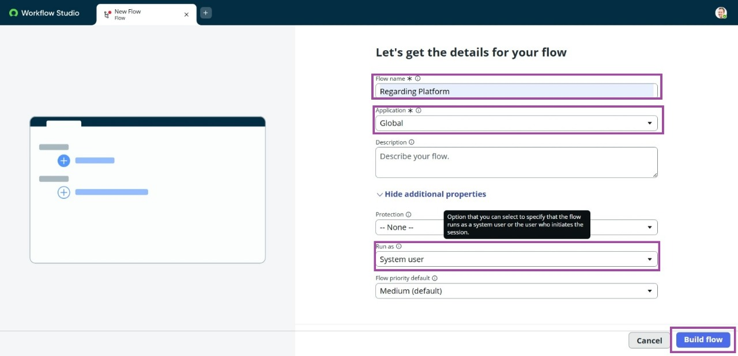

5. Click Submit.

* Add Trigger

6. Click Add a Trigger.

7. Choose Create or Update a Record.

8. Table: Operations Related

9. Add Conditions:

Criteria 1 → Field: Issue, Operator: is, Value: Unable to login to platform

Criteria 2 → Field: Issue, Operator: is, Value: 404 Error

Criteria 3 → Field: Issue, Operator: is, Value: Regarding User expired

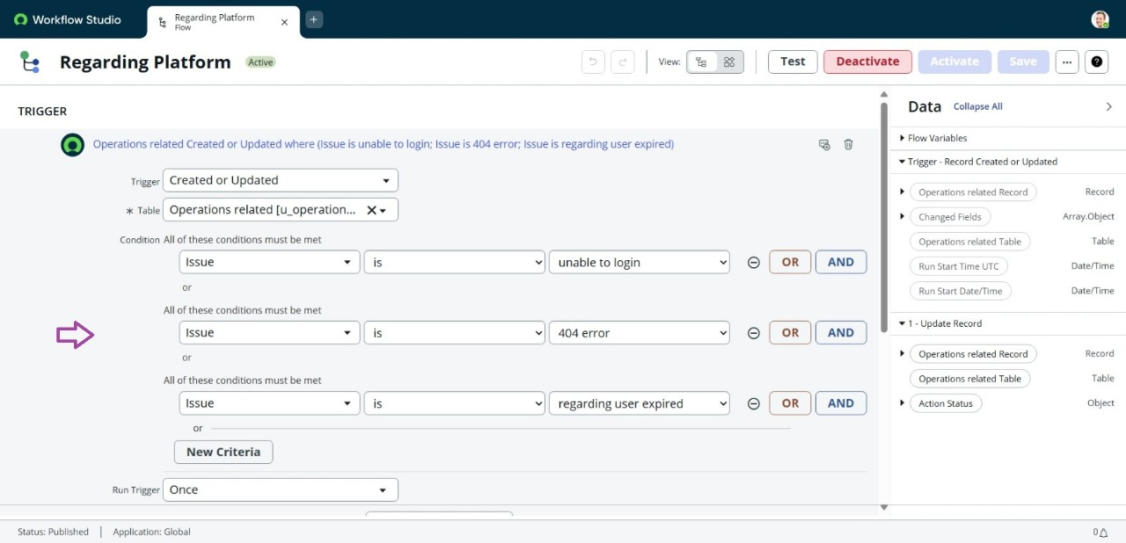

10. Click Done.

* Add Action

11. Under Actions, click Add an Action.

12. Select Update Record.

13. From the Data Panel on the left, drag the required fields.

14. Table will be auto-assigned.

15. Field: Assigned to group

16. Value: Platform

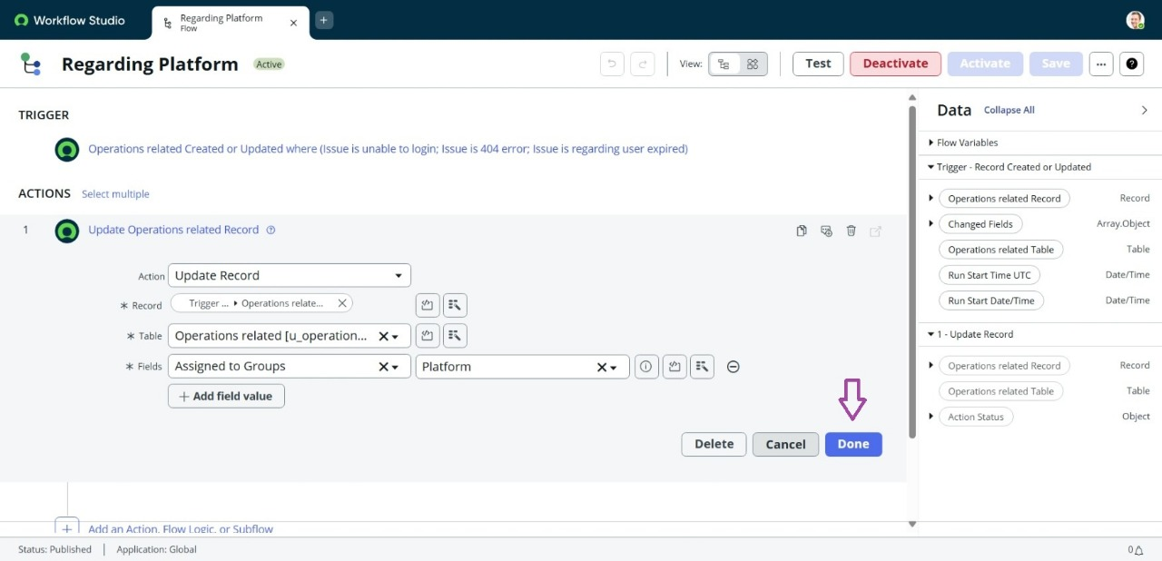

17. Click Done.

18. Click Save, then Activate the flow.

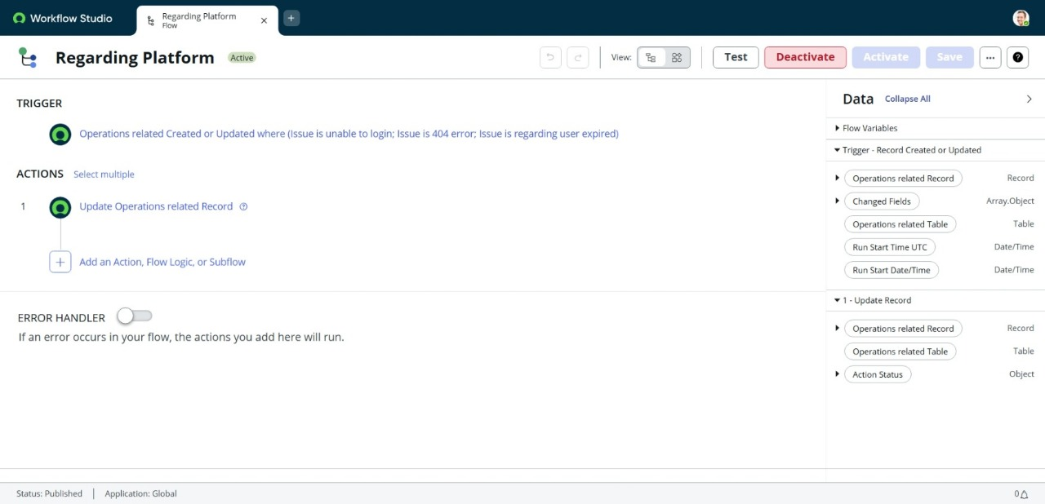

**CONCLUSION**:

This Project Successfully Automated Ticket Assignment InServicenow, Reducing Manual Effort And Delays. By Assigning Proper Roles, Groups, And Flows, Tickets Are Now Routed ToThe Right Teams Instantly.

The Streamlined Process Ensures Quicker Response Times And Improved Productivity. Automation Also Minimizes Human Errors, Making Support Operations More Reliable.

Overall, The Project Highlights How Servicenow Can Transform Ticket Management IntoA Smarter And Efficient System.